

# ASSESSMENT FORM

**Course: ISYS6123 Introduction to Database Systems Method of Assessment: Performance Task Semester/Academic Year :** 2/2022-2023

# Name of Lecturer : CHARLES BERNANDO, S.Si., M.A., Ph.D.

**Date : 6 June 2023**

# Class : LK11

**Topic : Entity Relationship Modeling, SQL Data Definition (Table, Index), SQL Data Manipulation (Basic) , SQL Data Definition (View), SQL Data Manipulation (Advanced)**

1. Yoseph Adi Nugroho Tansil - 2602112865
2. Jeff Nathan Setiawan - 2602112524
3. Ruben Heryasyah - 2602117443
4. Rafael Gerrald Yehezkiel Tinambunan - 2602121863

**Group Members :**

# Student Outcomes:

**SO 1 - Able to analyze a complex computing problem and to apply principles of computing and other relevant disciplines to identify solutions;**

**L.Obj 1.1 - Able to identify the needs of database for complex computing problems;**

|  |  |  |  |  |  |  |  |  |
| --- | --- | --- | --- | --- | --- | --- | --- | --- |
| **No** | **Assessment criteria** | **Weight** | **Excellent (85 - 100)** | **Good (75-84)** | **Average (65-74)** | **Poor (0 - 64)** | **Score** | **(Score x Weight)** |
| 1 | Ability to develop Data Definition Language (DDL) | **30%** | The DDL is complete and describes all the tables and constraints | The DDL misses 1-2 tables or constraints | The DDL misses 3-5 tables or constraints | The DDL misses more than 5 tables or constraints |  |  |
| 2 | Ability to insert data to table using Data Manipulation Language (DML) | **20%** | All data in all tables is realistic for the application, and all data in all tables supports the application. | All data in the tables reflects realistic data for the application, and one or two data items in all tables do not support the application. | One to four data items in the tables do not reflect realistic data for the application, and more than two data items in all tables do not support the  application | More than four data items in the tables are missing or contains not realistic data for the application. |  |  |
| 3 | Ability to create View using Data Manipulation Language (DML) Basic and Advanced | **20%** | Minimum 1 view using DML Basic and minimum 1 view using DML Advanced, and each view displays correct data | Minimum 1 view using DML Basic and minimum 1 view using DML Advanced, with 1 or 2 errors in the creation of view | Minimum 1 view using DML Basic and minimum 1 view using DML Advanced, with 3 to 4 errors in the creation of view | Minimum 1 view using DML Basic and minimum 1 view using DML Advanced, with more than 4 errors in the creation of  view |  |  |
|  | **Total Score:** ∑(Score x Weight) | | | | | | |  |

Remarks:

# ASSESSMENT METHOD

CASE STUDY

**Information Systems E-Marketplace Photographers**

In this era, photography is the one of desirable job for several people. We need professional photographer to capture our special moments, such as pre wedding, wedding reception, corporate event, birthday party, and so on. Commonly to hire professional photographer we deal with Bridal, Wedding O 0rganizer, or directly to the photographer based on our relatives. According to our technology development, now we can do transaction by using internet, and interact directly with sellers. This mechanism we called it e-marketplace.

Anthony is one of photographer who wants to promote her portfolio by using internet to attract customers, while Rebecca is one of clients who wants to hire professional photographer for her pre wedding but she has no time to go to the bridal because she is a busy woman with daily activities tight schedule. Based on this situation, a group of young entrepreneurs wants to build photographer e-marketplace website and wants to use Ms. SQL Server software as their database software.

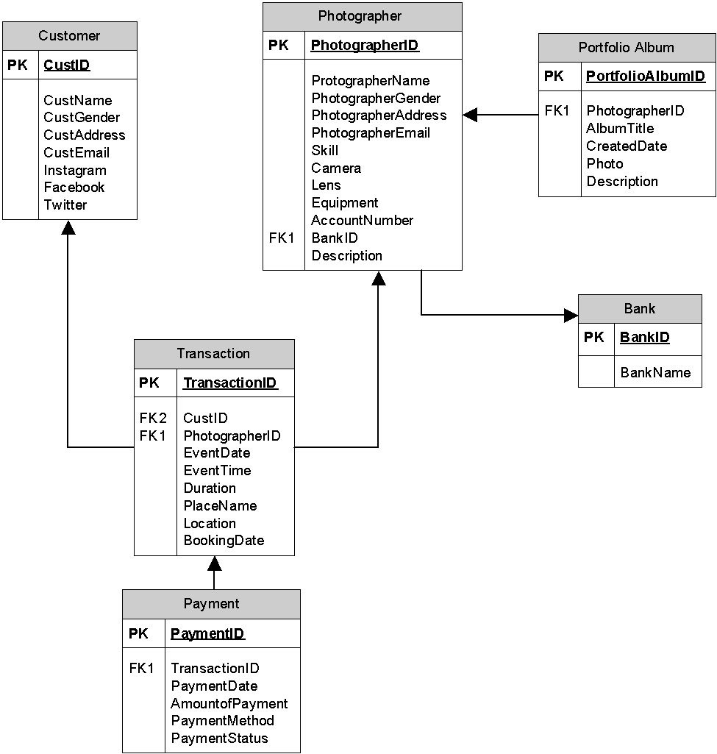

# EXERCISE

1. Write DDL query to create the above 6 tables
2. Rebecca (CustID = ‘5’) then books Anthony (PhotographerID = ‘P01’) on October 11, 2022 for her pre-wedding event on Nov 25, 2022, starting from 08.00 to 17.00 (duration of 9 hours). The place name is Ranca Upas, which is located in Bandung. Write a query to insert this transaction to the above table
3. Create View that apply:
   1. Inner Join
   2. Outer Join
   3. Set Operators
   4. Sub Query IN
   5. Sub Query EXISTS

# ANSWER

1. DDL Query to create 6 tables:

CREATE TABLE Customer (

CustID INT PRIMARY KEY,

CustName VARCHAR (50) NOT NULL, CustGender VARCHAR (10) NOT NULL, CustAddress VARCHAR(100) NOT NULL, CustEmail VARCHAR(50) NOT NULL, Instagram VARCHAR(50) NOT NULL, Facebook VARCHAR(50) NOT NULL, Twitter VARCHAR(50) NOT NULL

)

CREATE TABLE Photographer (

PhotographerID VARCHAR (10) PRIMARY KEY, PhotographerName VARCHAR (50) NOT NULL, PhotographerGender VARCHAR (10) NOT NULL, PhotographerAddress VARCHAR (50) NOT NULL, PhotographerEmail VARCHAR (50) NOT NULL, Skill VARCHAR (50) NOT NULL,

Camera VARCHAR (50) NOT NULL, Lens VARCHAR (50) NOT NULL, Equipment VARCHAR (50) NOT NULL,

AccountNumber INT NOT NULL,

BankID VARCHAR (10) REFERENCES Bank(BankID),

Description VARCHAR (100) NOT NULL

)

CREATE TABLE PortfolioAlbum ( PortfolioAlbumID INT PRIMARY KEY,

PhotographerID VARCHAR (10) REFERENCES Photographer(PhotographerID), AlbumTitle VARCHAR (50) NOT NULL,

CreatedDate DATE NOT NULL, Photo INT NOT NULL,

Description VARCHAR(100) NOT NULL

)

CREATE TABLE Bank (

BankID VARCHAR (10) PRIMARY KEY, BankName VARCHAR (25) NOT NULL

)

CREATE TABLE Transaction(

TransactionID VARCHAR (10) PRIMARY KEY,

CustID INT REFERENCES Customer(CustID),

PhotographerID VARCHAR (10) REFERENCES Photographer(PhotographerID), EventDate DATE NOT NULL,

EventTime TIME NOT NULL, Duration INT NOT NULL,

PlaceName VARCHAR (50) NOT NULL,

Location VARCHAR (50) NOT NULL,

BookingDate DATE NOT NULL

)

CREATE TABLE Payment (

PaymentID VARCHAR (10) PRIMARY KEY,

TransactionID VARCHAR (10) REFERENCES Transaction(TransactionID) , PaymentDate DATE NOT NULL,

AmountofPayment INT NOT NULL, PaymentMethod VARCHAR (50) NOT NULL, PaymentStatus VARCHAR (20) NOT NULL

)

ANSWER NO. 2

INSERT INTO Transaction (CustID, PhotographerID, EventDate, EventTime, Duration, PlaceName, Location, BookingDate) VALUES (‘5’, ‘P01’, ‘2022-11-25’, ‘08:00:00’, ‘9’, ‘Ranca Upas’, ‘Bandung’, ‘2022-10-11’)

ANSWER NO. 3

# - Inner Join

CREATE VIEW CustomerTransactionView AS

SELECT c.CustID, c.CustName, t.TransactionID, t.BookingDate FROM customer c

INNER JOIN transaction t ON c.CustID = t.CustID

# - Outer Join

CREATE VIEW PhotographerTransactionView AS

SELECT *

FROM Photographer

FULL OUTER JOIN Transaction

ON Photographer.PhotographerID = Transaction.PhotographerID

# - Set Operators

CREATE VIEW SetOperatorsView AS

SELECT CustName, CustEmail FROM Customer

UNION

SELECT PhotographerName, PhotographerEmail FROM Photographer

**- Sub Query IN** CREATE VIEW ViewSubquery AS

SELECT *

FROM Transaction WHERE CustID IN

(SELECT CustID

FROM Customer

WHERE CustGender = 'Female')

**- Sub Query EXISTS** CREATE VIEW SubqueryExistsView AS

SELECT *

FROM Photographer p WHERE **EXISTS**

(SELECT *

FROM Payment

WHERE PhotographerID = p.PhotographerID)